Wasteless Application

Analysis and Design Document

Student: Sabou Cezara

**Group: 30431**

Table of Contents

1. Requirements Analysis 3

1.1 Assignment Specification 3

1.2 Functional Requirements 3

1.3 Non-functional Requirements 3

2. Use-Case Model 3

3. System Architectural Design 3

4. UML Sequence Diagrams 3

5. Class Design 3

6. Data Model 3

7. System Testing 3

8. Bibliography 3

* Requirements Analysis

# Assignment Specification

This application is meant to improve the management of food waste. It is an Angular and Spring Boot full stack application, which is based on a client-server architecture. The server is constructed in a layered manner, and has three main layers: the presentation, the business and the persistence layer. The application was created in order to help the user manage their food waste, therefore the user can introduce grocery lists, and for each list some items. For each of these lists the user will be able to see if the waste levels exceed limits.

# Functional Requirements

*The requirements are the following:*

* *The user should be able to log into the page*
* *If the user does not yet have an account, there should be a registration page which will allow the user to create one*
* *After logging in, the user should be able to access the grocery lists previously created and add new lists*
* *A user should be able to open a grocery list item and add, delete or see the details of a certain grocery item*
* *Notifications should be sent to the user if the waste levels are too high*
* *The user should receive suggestions with options to donate the excess food*
* *The user should be able to see monthly/weekly reports of the waste details*

# Non-functional Requirements

*The non-functional requirements are:*

* *The user should not be allowed to alter the ideal burndown rate, nor the way the actual burndown rate is calculated*
* *The user should not be allowed to see the other user’s lists*
* *The user should not be allowed to access the grocery lists if the correct email and password was not provided*

2. Use-Case Model

*Use case: User login*

*Level: user-goal level*

*Primary actor: regular user*

*Main success* *scenario: the user successfully introduces the email and the password, and the main page opens*

*Extensions: the user fails to introduce the correct email and password and an error message is shown*

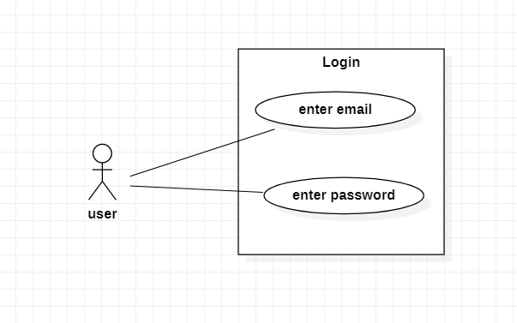

*Use case: Create Grocery list*

*Level: user-goal level*

*Primary actor: regular user*

*Main success scenario: the user successfully introduces the name of the grocery list and the new list appears, where the user can add and delete items.* 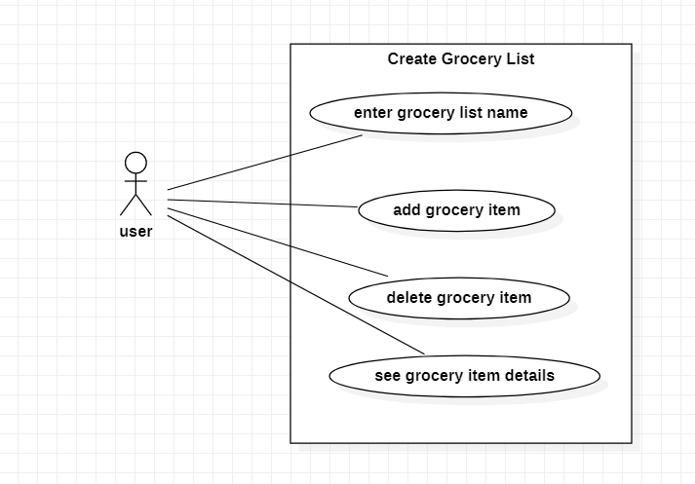

*Use case: Get waste levels*

*Level: user-goal level*

*Primary actor: regular user*

*Main success scenario: the user successfully introduces the day and the calorie goal, which is also called the ideal burndown rate, and then successfully presses the button “Waste level” of a specific list from the main page. A message appears on the screen with the current calorie number and also, if the waste level is too high, if it exceeds the goal, then the user is notified through an alert message.*

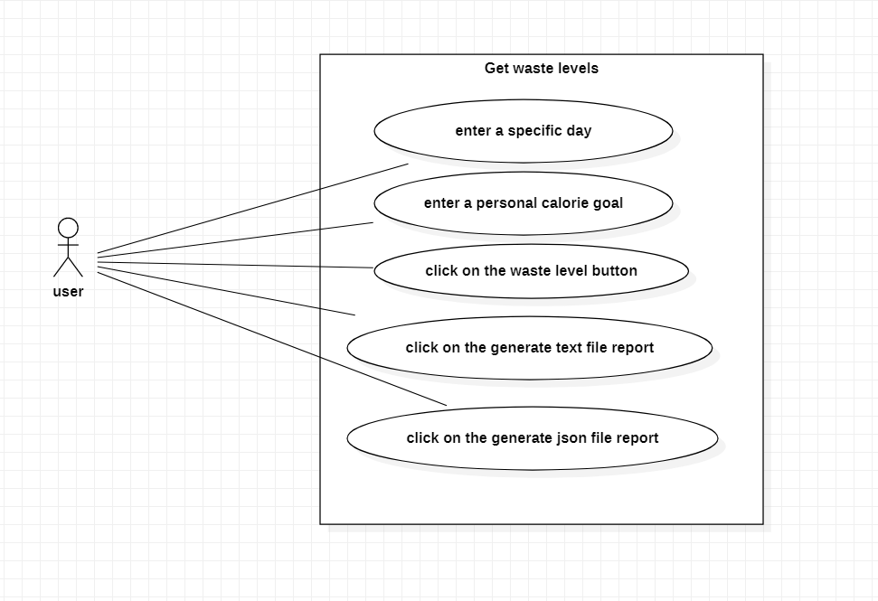

3. System Architectural Design

**3.1 Architectural Pattern Description**

*The application is split into two parts: the frontend and the backend, and it represents a client-server architecture.*

*In the frontend, I used Angular 2 to design the application, and it represents the client side.*

*The layered architectural pattern was used in the backend, which is organized into horizontal layers, each of them having a specific role in the project. This project contains the following layers:*

* *Presentation layer*
* *Business layer*
* *Persistence layer*
* *Database*

*Also, another package called the model package is accessed by multiple layers, as it holds the data needed for the database, as well as for the frontend part.*

**3.2 Diagrams**

*[Create the system’s conceptual architecture; use architectural patterns and describe how they are applied. Create package, component and deployment diagrams]*

*The system’s conceptual architecture is the same as the one described in the course, which is layered:*

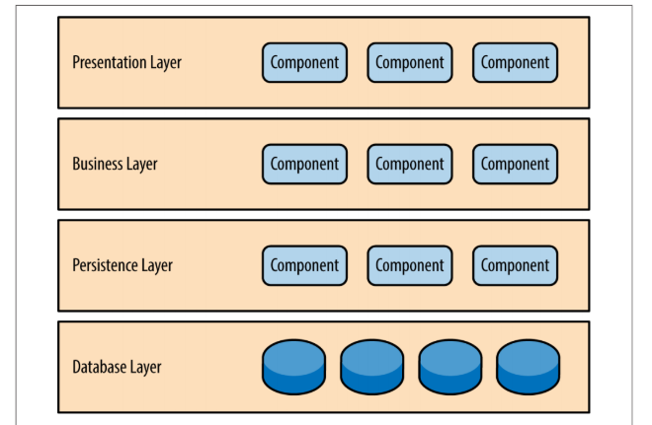

4. UML Sequence Diagrams

*[Create a sequence diagram for a relevant scenario.]*

*This is the sequence diagram for calculating the waste level:*

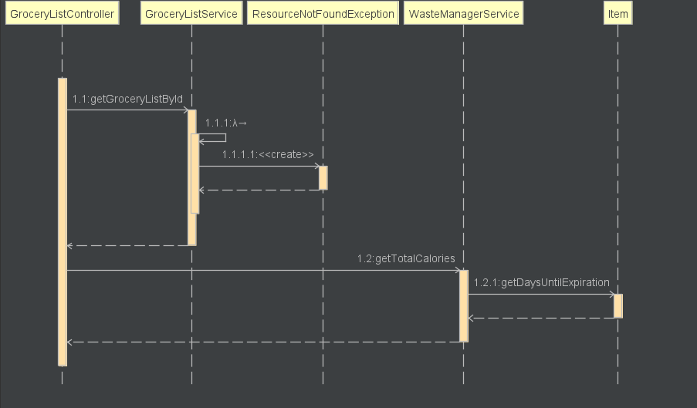

*And this is another sequence diagram, which represents getting an item from the database, based on the id:*

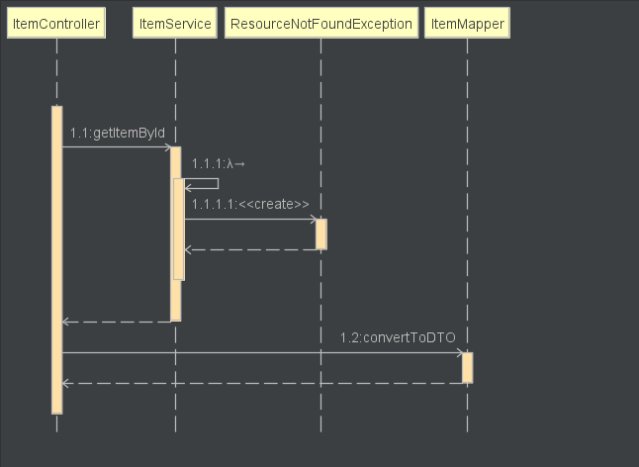

5. Class Design

**5.1 Design Patterns Description**

*The design pattern used in this project is the Abstract Factory Pattern. This pattern allows us to create objects which follow a general pattern. It consists of an interface which is created for operations that create abstract product objects, to be more specific, it creates families of object. For showing this property of the abstract factory pattern, the reports were generated in this manner, just as they are shown in this class diagram. I chose to allow the user to choose if they wanted to generate a text file report or a json file report, and so these two classes inherited the Report interface.*

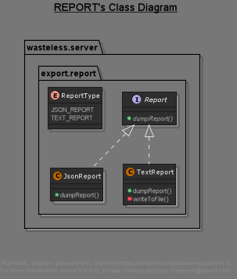

**5.2 UML Class Diagram**

*In this image there is the actual representation of the architecture chosen, which is the layered architecture. And the classes were designed to fit the layered architecture. Therefore, whenever the client issues a request, the data goes through the presentation layer, where for each data type, Item, User or Grocery list, there is a specific controller which*

*\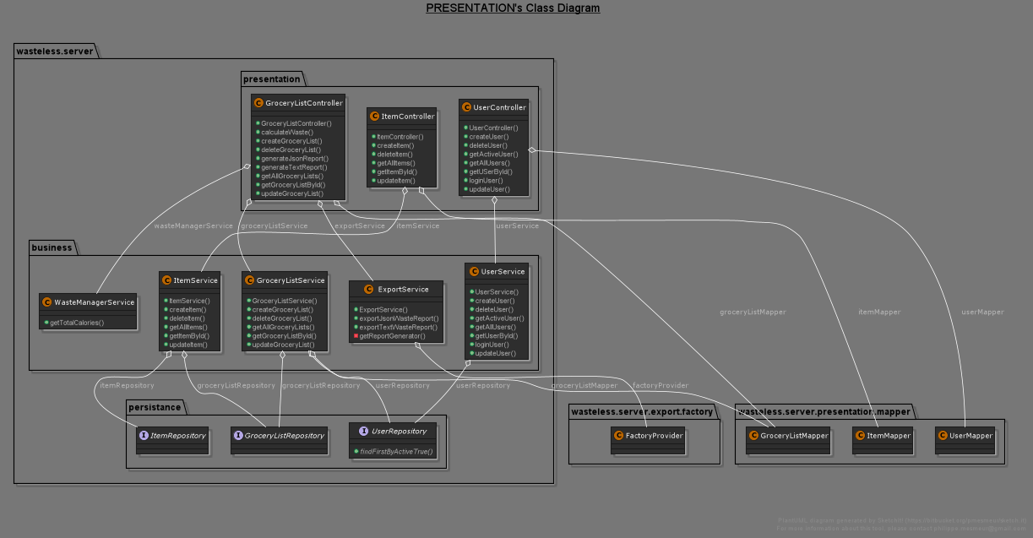*

6. Data Model

*This is the data model. I chose to have 3 data models:*

1. *The Item class.*

*This class holds all the attributes about the item object:*

* 1. *The item id*
  2. *The quantity*
  3. *The calorie value*
  4. *The purchase date*
  5. *The consumption date*
  6. *The expiration date*

1. *The User class.*

*This class contains information about the user:*

* 1. *The user id*
  2. *First name*
  3. *Last name*
  4. *Email address*
  5. *Password*
  6. *A personal list of grocery lists*

1. *The Grocery List class:*

*This class holds the information about a grocery list:*

* 1. *The grocery list id*
  2. *The grocery list name*
  3. *The list of items*

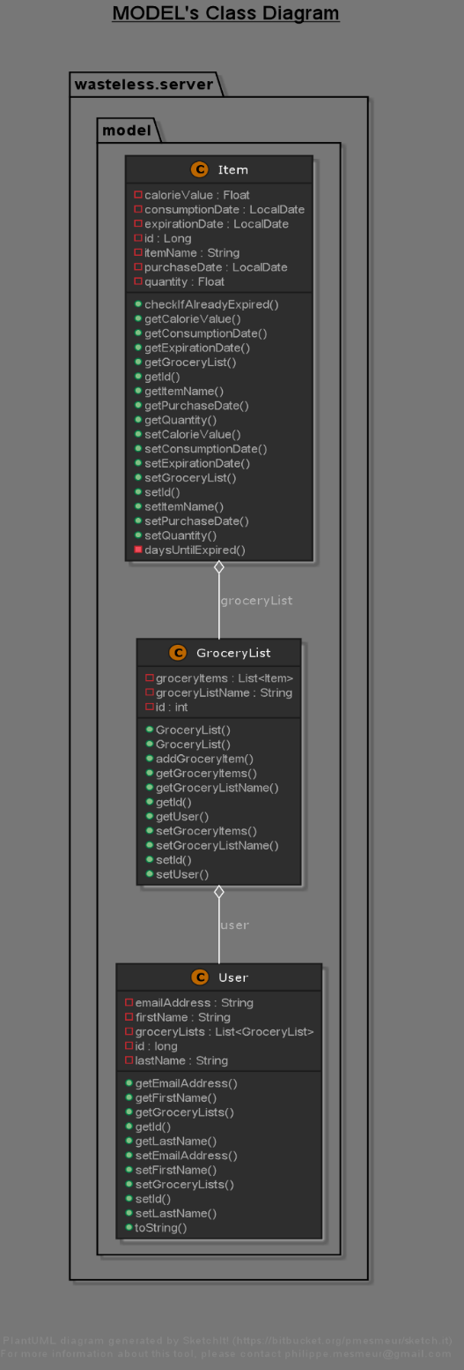

7. System Testing

*[Present the used testing strategies (unit testing, integration testing, validation testing) and testing methods (data-flow, partitioning, boundary analysis, etc.).]*

*For the testing part, I chose to use unit testing.*

*I will show the functionality of the application here:*

*The Register page, where the user inputs their data and it is saved into the database:*

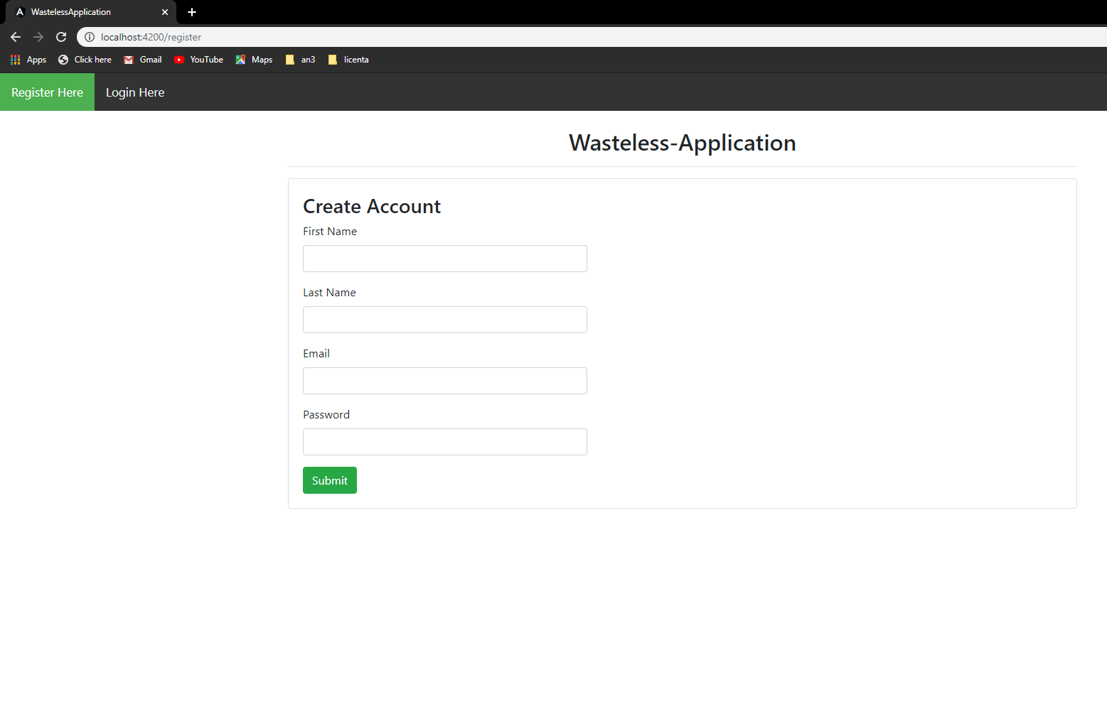

*The Login page, where the user can input their email and password, and if the credentials do not match the ones in the database, then they cannot enter to see their grocery lists:*

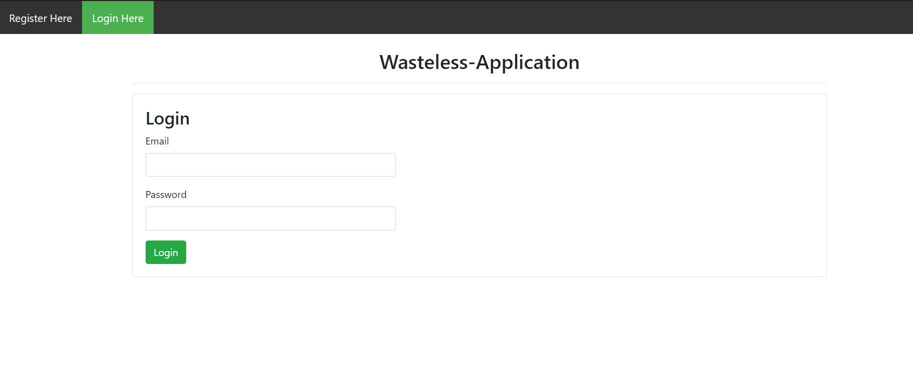

*The main page, where the user can see all the grocery lists previously entered.*

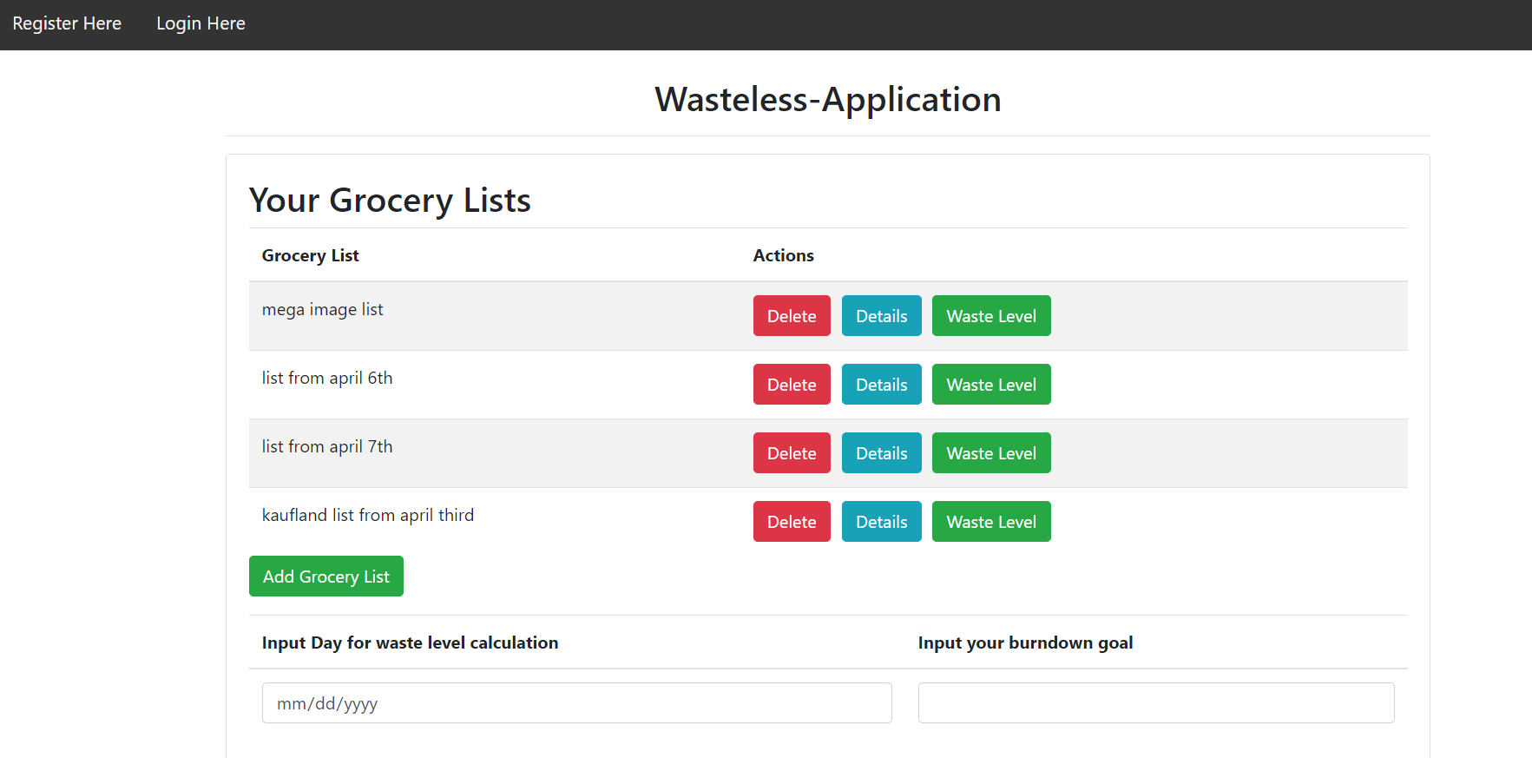

*And he can do the following operations:*

* *Create a new list, where they can enter the name of the list and then they are taken to the page list* 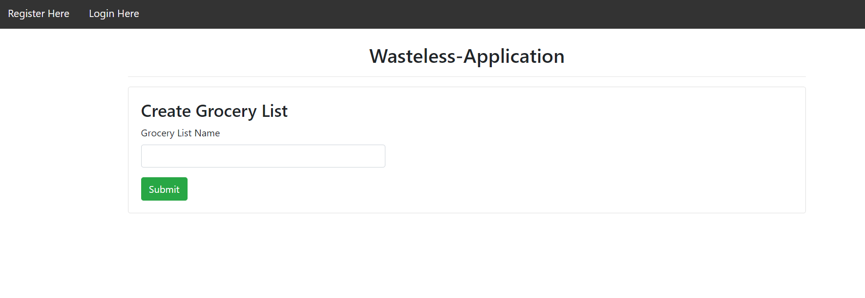

*After entering the name, the user can keep adding items to the list or go to the main page*

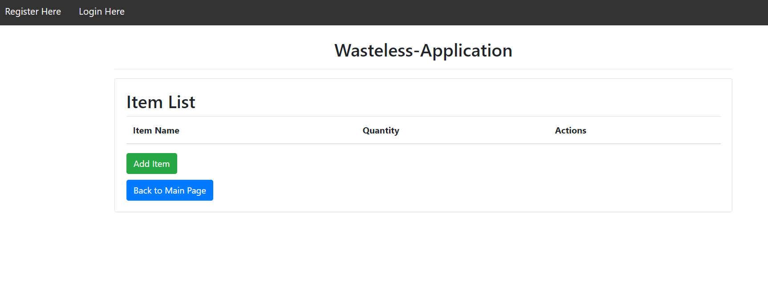

*A completed list looks like this:*

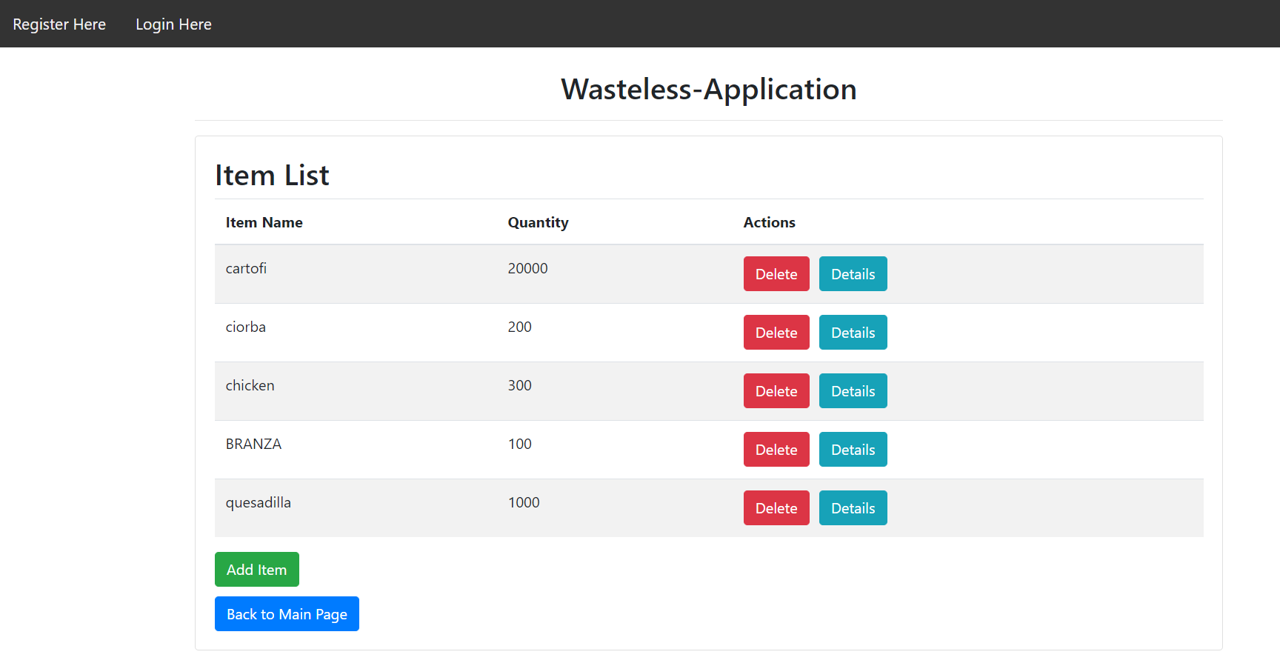

*If you click on Add Item, you are taken to the Add Item page:*

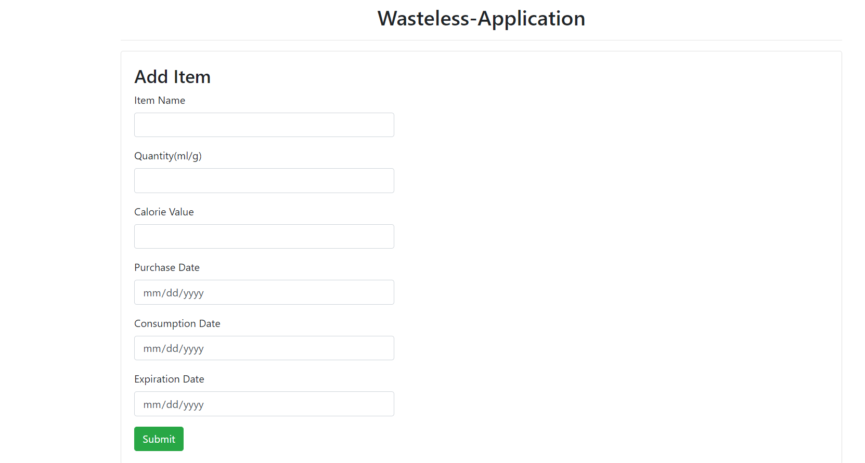

*If you click on the Details button, then you are taken to the Item Details page, where you can see all the information about a certain item:*

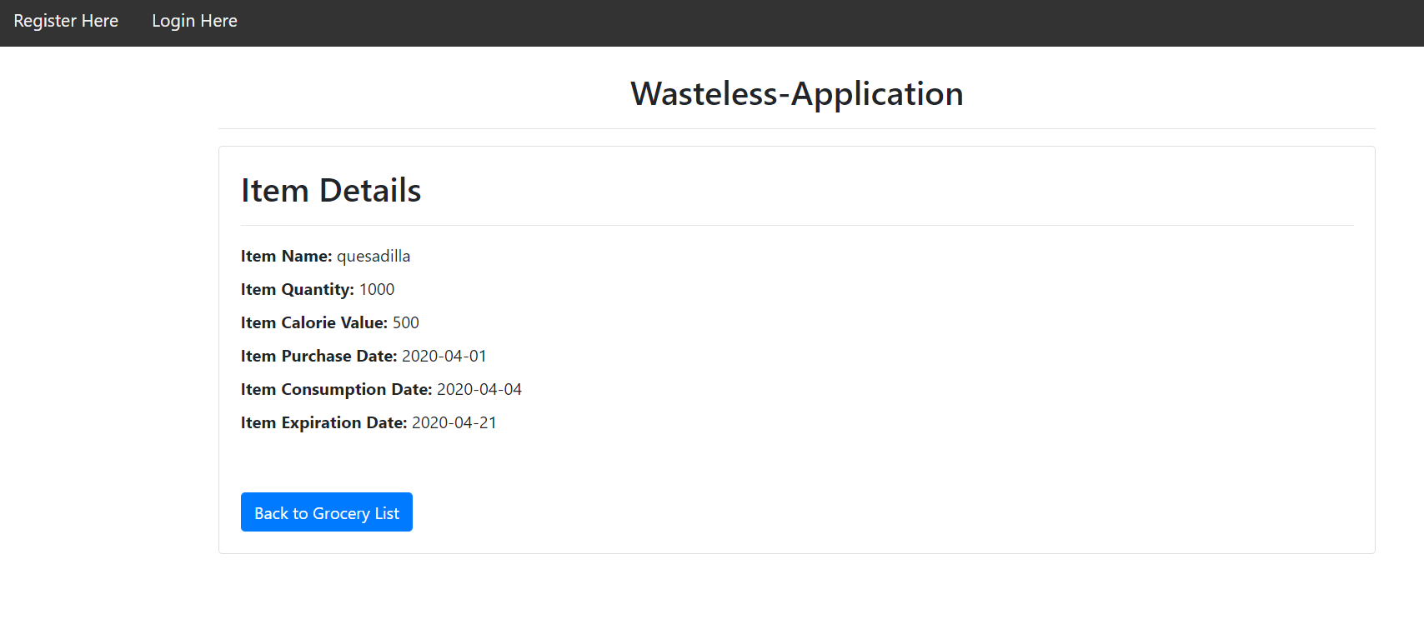

* *Delete a list*
* *See the details of a list*
* 
* *Input the day and the burndown goal and press the waste level of a certain list. If the waste level is too high, then, the user will get an error message. If the waste levels were correctly calculated, then the user can choose if they want to generate a text or json report by pressing on the newly appeared buttons: Generate Text Report and Generate Json report.*

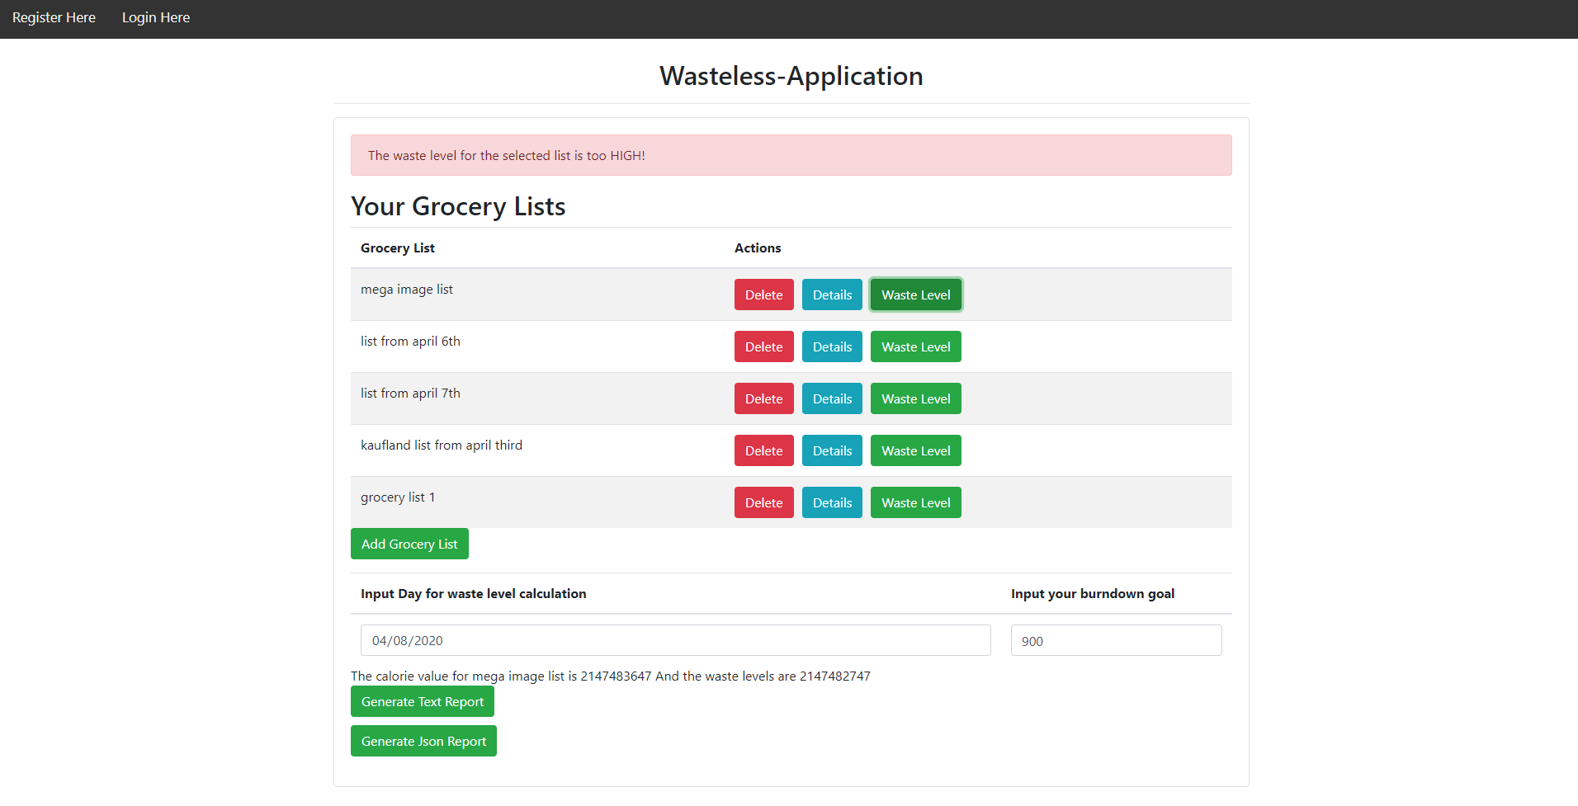

*entered*

8. Bibliography

<https://www.baeldung.com/java-abstract-factory-pattern>

<https://angular.io/tutorial/>

<https://www.javatpoint.com/angular-spring-crud-example>